Specific Reports available for Arbor Migration checks
ARBOR - Migration check - Guardians - PG1 and PG2 only.wls
ARBOR - Migration check - Staff Contracts.wls
ARBOR - MIgration check - Staff List excluding contracts.wls
ARBOR - Migration check - Student List including contextual data.wls
ARBOR - Migration Report - Staff Absences.wls
These reports can be found under Reports > Adhoc Flexible Reporting > Integris Reports.
To run a report, select it and then click on the icon. If you just want to run for current students, then click Submit and the report will run.
If you want to include former students as well, click on the 3 dots next to Roll status drop down (see below)
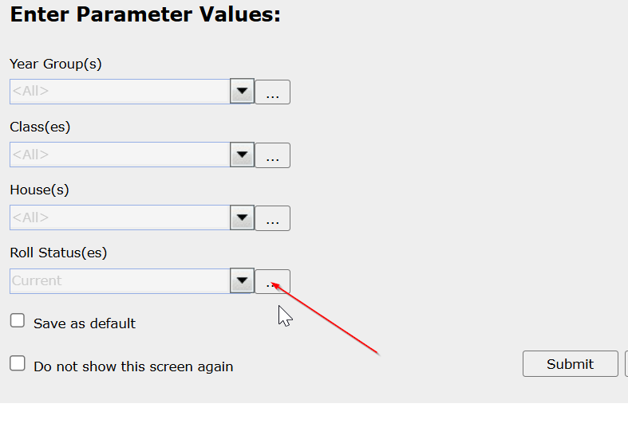
Click the 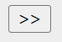 and move all the options across and click OK.
Then submit the report
The staff report will run for all staff current and former

As there is a lot of data in each report, we would strongly advise exporting the reports to excel. Allow the report to appear and then click on the export button  on the toolbar.
In Format select Excel
In Version select Excel Workbook
in Format select Column Format and then click OK
A file will be created in your download folder which can then be opened in Excel or Google Sheets.

I don’t have Adhoc Flexible on my menu
If you are an Admin user then you can continue with these instructions. If you are not then you will need your Integris Admin to complete the instructions.
- Go to Modules > System Management > User Management
- Select your account and click the pencil to edit
- Click on the roles tab
- Find the roles
AdhocReportStaffAll
AdhocReportStudAll
CreateFlexibleReport
FlexibleReportUser
and add them by clicking the Add button (they should then appear on the right hand side box.
- Click Save
- Now exit User Management by clicking Close and logout of Integris (this is essential otherwise the new roles do not apply)
- Log back into Integris and the new menu option should show on the Reports menu

